1. SCALABILITY
   1. DEFINITION

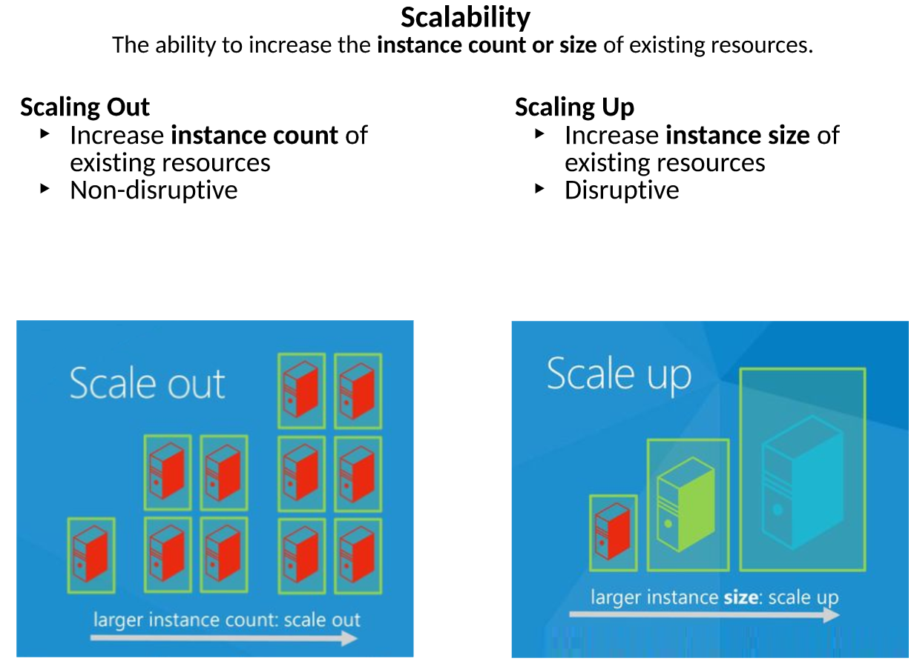

* 1. SCALE OUT – Non Disruptive Change – We don’t have to take any machines off line to SCALE OUT.
  2. There are 2 ways to scale and provides flexibility to increase the resources as you need based on the traffic to your site or workload that our sites are performing.